FLYNN SELF SERVICE PORTAL - REFERENCE GUIDE

SN Self Service Portal Link (Compatible w/ tablet and mobile device)
https://flynnprod.service-now.com/sp
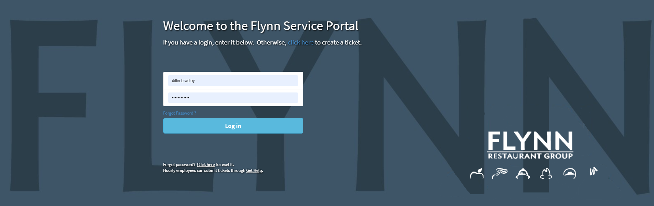
• If you need to reset your Self-Service Portal password, click on the forgot password link on the main landing page (shown above) For Cafés/Stores, this will be your stores email address
* For security purposes, when a manager is transferred or terminated from your location, please reset the Self Service Portal password. The new password will need to be shared with your managers.
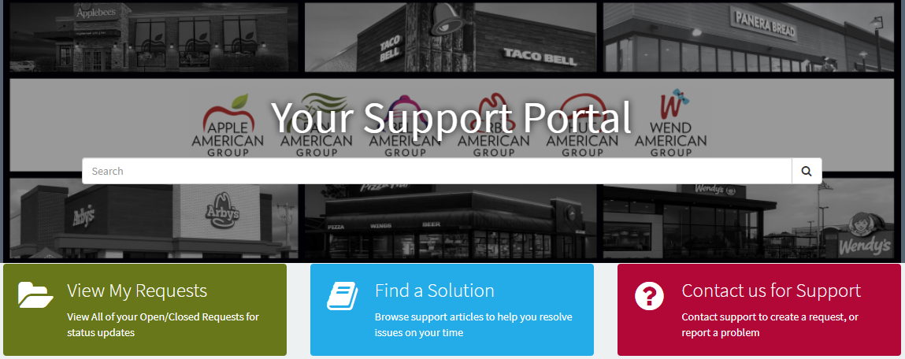
General Navigation
• View My Requests – View Your Open/Closed Requests
• Find a Solution – Search Our Knowledge Base for Self Help documents to resolve any issues
• Contact us for Support – Contact the Flynn Support Teams for assistance

Support Types
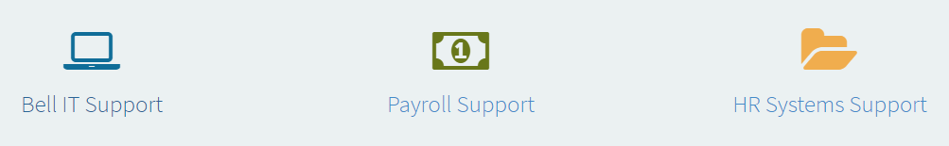
- IT Support – This will Show Common Issues, as well as an Unlisted Issue option
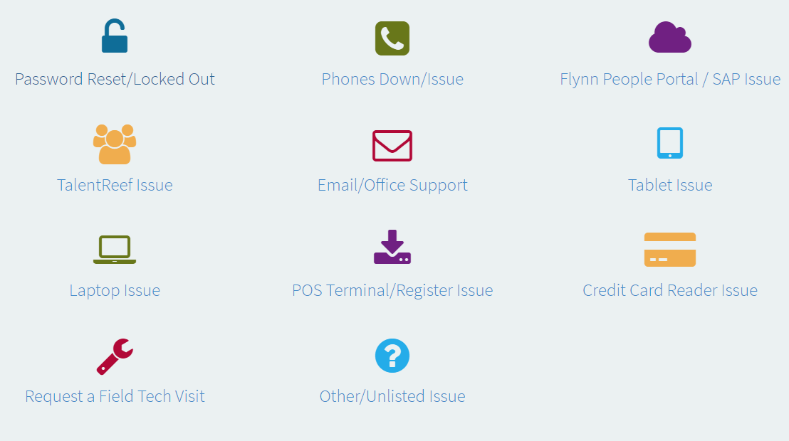
- Payroll Support - This will Show Common Issues, as well as an Individual Inquiry option
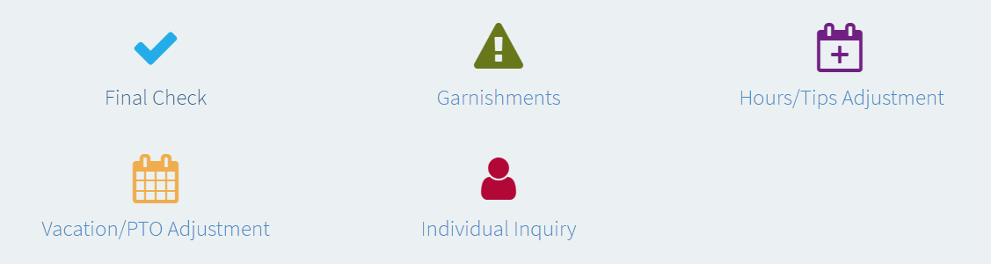
- HR Systems Support - This will Show Common Issues and an Other HR Systems Inquiry option
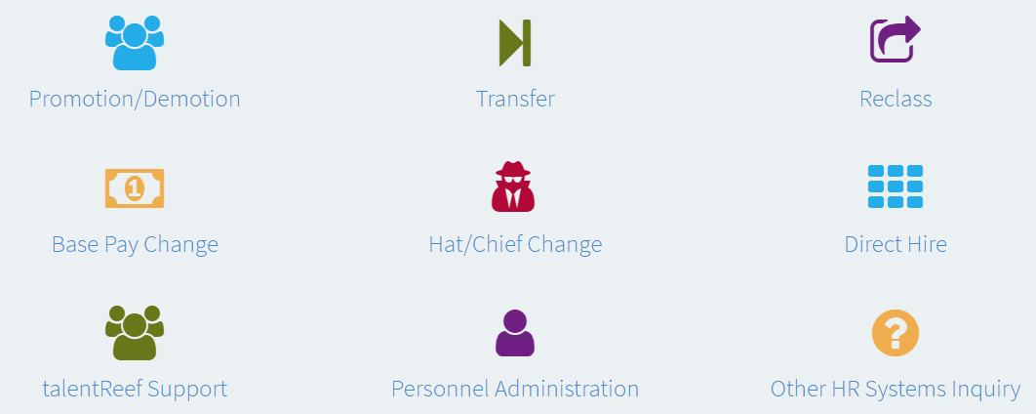

Other Navigation
- Announcements – Any Important announcements
- My Surveys – Open Surveys awaiting your feedback!
- Equipment Requests – Open Requests for New/Replacement Equipment
- Issue Reports – Reporting to show your current existing Issue Requests (For AD’s and DO’s, you will be able to see your Area/Market)
- Resources – Who to Contact Lists
- Top Rate Articles – 5 of the top-rated Self-Help Articles
